MICROCONTROLLER BASED

AUTOMATIC RAILWAY

GATE CONTROL

A Project Report
On
Microcontroller based automatic railway gate control
A Project report submitted in partial fulfillment of the requirements
For the award of the diploma in

ELECTRICAL & ELECTRONICS ENGINEERING
By
G.PRUDVI RAJ 16027-EE-217
Under the Esteemed Guidance of
Miss. B.SRUJANA _{B.Tech}
Lecturer in Electrical & Electronics Engineering

DEPARTMENT OF ELECTRICAL & ELECTRONICS ENGINEERING
GOVERNMENT POLYTECHNIC NALGONDA STATE BOARD OF TECHNICAL EDUCATION & TRAINING, TELANGANA
2016-2019
APPROVED BY A.I.T.E. AND CERTIFIED FROM S.B.T.E.T.
GOVERNMENT POLYTECHNIC NALGONDA
STATE BOARD OF TECHNICAL EDUCATION & TRAINING, TELANGANA

CERTIFICATE
This is to certify that project entitled “Microcontroller Based Railway Gate Control” is a bonafide work done by G.PRUDVI RAJ 16027-EE-217in partial fulfillment of the requirements for the award of DIPLOMA IN ELECTRICAL & ELECTRONICS ENGINEERING by SBTET, TS during the academic year 2018-2019...
The results presented in this project have been verified and are found to be satisfactory.

PROJECT GUIDE HEAD OF THE DEPARTMENT
B.SRUJANA _{B .Tech} A.Venkata Ramana _{M.Tech}

PRINCIPAL EXTERNAL EXAMINER
N.SRINIVASA RAO _{M .Tech}

ACKNOWLEDGEMENT

I write this acknowledgement with great honor, pride and pleasure to pay my respects to all who enabled me either directly or indirectly in reaching this stage.

I would like to pay respectful thanks to our Principal Mr. N.SRINIVASA RAO and management for providing all the facilities required for completing this project work.
I express my profound thanks to Dr. A.VENKATA RAMANA, Head of Electrical and Electronics Engineering Department for unflinching devotion, which lead me to complete this project.
I am indebted forever to my guide Miss. B.SRUJANA, Lecturer in Electrical and Electronics Engineering for his suggestions, guidance and inspiration in carrying out this project work.
I wish to extend my sincere thanks to my parents and others, for their understanding and co-operation during the course of my project work.

I take this opportunity to convey my sincere thanks to all my classmates who have directly and indirectly contributed for the successful completion of this work

Abstract

The objective of this project is to provide an automatic railway gate at a level crossing replacing the gates operated by the gatekeeper. It deals with two things. Firstly, it deals with the reduction of time for which the gate is being kept closed. And secondly, to provide safety to the road users by reducing the accidents.

By the presently existing system once the train leaves the station, the stationmaster informs the gatekeeper about the arrival of the train through the telephone. Once the gatekeeper receives the information, he closes the gate depending on the timing at which the train arrives. Hence, if the train is late due to certain reasons, then gate remain closed for a long time causing traffic near the gates.

By employing the automatic railway gate control at the level crossing the arrival of the train is detected by the sensor placed near to the gate. Hence, the time for which it is closed is less compared to the manually operated gates and also reduces the human labour. This type of gates can be employed in an unmannered level crossing where the chances of accidents are higher and reliable operation is required. Since, the operation is automatic; error due to manual operation is prevented.

Automatic railway gate control is highly economical microcontroller based arrangement, designed for use in almost all the unmanned level crossings in the country. In this we mainly use motors which are controlled by Microcontroller and they are sensed by IR sensors. The microcontroller is powered by DC supply. When the IR sensor senses the signal and it triggers the buzzer circuit. And the motors are controlled by the microcontroller when sensor gives signal then the gates are closed on either sides of the railway track. This is the main working of this project Microcontroller based automatic railway gate control.

INDEX
Topics Page Number

- CHAPTER 1: INTRODUCTION 7 -9

  - Introduction of the project
  - Project Overview
  - Thesis

- CHAPTER 2: ARDUINO 10 - 13

2.1 Introduction to Adruino
2.2 Need of Adruino
2.3 What does Arduino do?

- CHAPTER 3: HARDWARE DESCRIPTION 16 - 34

3.1 Microcontroller
3.2 Regulated power supply
3.3 LED
3.4 Servo motor
3.5 Ultrasonic sonic sensor
3.6 Buzzer
3.7 Hall Effect Sensor

- CHAPTER 4: SOFTWARE DESCRIPTION 35 - 37

4.1 Arduino IDE
4.2 Usage of Arduino IDE
4.3 Dumping of program into Arduino board

- CHAPTER 5 : PROJECT CIRCUIT DIAGRAM 38 - 40
- CHAPTER 6 : ADVANTAGES , DISADVANTAGES
AND APPLICATIONS 41-43
- CHAPTER 7 : RESULT,CONCLUSION,FUTURE
PROSPECTS REFERENCES 44

CHAPTER: 1

INTRODUCTION

Introduction:

The objective of this paper is to provide an automatic railway gate at a level crossing replacing the gates operated by the gatekeeper. It deals with two things. Firstly, it deals with the reduction of time for which the gate is being kept closed. And secondly, to provide safety to the road users by reducing the accidents
By the presently existing system once the train leaves the station, the stationmaster informs the gatekeeper about the arrival of the train through the telephone. Once the gatekeeper receives the information, he closes the gate depending on the timing at which the train arrives. Hence, if the train is late due to certain reasons, then gate remain closed for a long time causing traffic near the gates.
By employing the automatic railway gate control at the level crossing the arrival of the train is detected by the sensor placed near to the gate. Hence, the time for which it is closed is less compared to the manually operated gates and also reduces the human labor. This type of gates can be employed in an unmanned level crossing where the chances of accidents are higher and reliable operation is required. Since, the operation is automatic; error due to manual operation is prevented.
Automatic railway gate control is highly economical microcontroller based arrangement, designed for use in almost all the unmanned level crossings in the country.

1.2

Project Overview:

An embedded system is a combination of software and hardware to perform a dedicated task. Some of the main devices used in embedded products are Microprocessors and Microcontrollers.
Microprocessors are commonly referred to as general purpose processors as they simply accept the inputs, process it and give the output. In contrast, a microcontroller not only accepts the data as inputs but also manipulates it, interfaces the data with various devices, controls the data and thus finally gives the result.
The Automatic railway gate control system using 16F877A Microcontroller is an exclusive project that can control the railway gate according to the instructions given by the above said microcontroller.

1.3
Thesis:

The thesis explains the implementation of “Automatic railway gate control system” using PIC16F877A microcontroller. The organization of the thesis is explained here with:

Chapter 1: Presents introduction to the overall thesis and the overview of the project. In the project overview a brief introduction of Automatic railway gate control system and its applications are discussed.
Chapter 2: Presents the topic embedded systems. It explains the about what is embedded systems, need for embedded systems, explanation of it along with its applications.
Chapter 3: Presents the hardware description. It deals with the block diagram of the project and explains the purpose of each block. In the same chapter the explanation of microcontroller, power supplies, DC motor and IR transmitter and IR receiver are considered.
Chapter 4: Presents the software description. It explains the implementation of the project using PIC C Compiler software.
Chapter 5: Presents the project Circuit diagram.
Chapter 6: Presents the advantages, disadvantages and applications of the project.
Chapter 7: Presents the results, conclusion and future scope of the project.

CHAPTER: 2
ARDUINO

2.1

Introduction to Arduino Nano

The Arduino Nano is a small, complete, and breadboard-friendly board based on the ATmega328P (Arduino Nano 3.x). It has more or less the same functionality of the Arduino Duemilanove, but in a different package. It lacks only a DC power jack, and works with a Mini-B USB cable instead of a standard one.

Schematic and Design
Arduino Nano 3.0 (ATmega328): schematic, Eagle files.
Arduino Nano 2.3 (ATmega168): manual (pdf), Eagle files. Note: since the free version of Eagle does not
handle more than 2 layers, and this version of the Nano is 4 layers, it is published here unrouted, so users
can open and use it in the free version of Eagle.

Specif ications:

Microcontroller Atmel ATmega168 or ATmega328
Operating Voltage (logic
level) :5 V
Input Voltage
(recommended):7-12 V
Input Voltage (limits): 6-20 V
Digital I/O Pins 14 (of which 6 provide PWM output)
Analog Input Pins 8
DC Current per I/O Pin 40 mA
Flash Memory
16 KB (ATmega168) or 32 KB (ATmega328) of which 2 KB used by
bootloader
SRAM 1 KB (ATmega168) or 2 KB (ATmega328)
EEPROM 512 bytes (ATmega168) or 1 KB (ATmega328)
Clock Speed 16 MHz
Dimensions 0.73" x 1.70"

Power:
The Arduino Nano can be powered via the Mini-B USB connection, 6-20V unregulated external power
supply (pin 30), or 5V regulated external power supply (pin 27). The power source is automatically selected
to the highest voltage source.
The FTDI FT232RL chip on the Nano is only powered if the board is being powered over USB. As a result,
when running on external (non-USB) power, the 3.3V output (which is supplied by the FTDI chip) is not
available and the RX and TX LEDs will flicker if digital pins 0 or 1 are high.
Memory
The ATmega168 has 16 KB of flash memory for storing code (of which 2 KB is used for the bootloader); the
ATmega328 has 32 KB, (also with 2 KB used for the bootloader). The ATmega168 has 1 KB of SRAM and
512 bytes of EEPROM (which can be read and written with the EEPROM library); the ATmega328 has 2 KB
of SRAM and 1 KB of EEPROM.
Input and Output
Each of the 14 digital pins on the Nano can be used as an input or output, using pinMode(), digitalWrite(),
and digitalRead() functions. They operate at 5 volts. Each pin can provide or receive a maximum of 40 mA
and has an internal pull-up resistor (disconnected by default) of 20-50 kOhms. In addition, some pins have
specialized functions:
Serial: 0 (RX) and 1 (TX). Used to receive (RX) and transmit (TX) TTL serial data. These pins are connected to the corresponding pins of the FTDI USB-to-TTL Serial chip.
External Interrupts: 2 and 3. These pins can be configured to trigger an interrupt on a low value, a
rising or falling edge, or a change in value. See the attachInterrupt() function for details.
PWM: 3, 5, 6, 9, 10, and 11. Provide 8-bit PWM output with the analogWrite() function.
SPI: 10 (SS), 11 (MOSI), 12 (MISO), 13 (SCK). These pins support SPI communication, which,
although provided by the underlying hardware, is not currently included in the Arduino language

LED: 13. There is a built-in LED connected to digital pin 13. When the pin is HIGH value, the LED is on,
when the pin is LOW, it's off.
The Nano has 8 analog inputs, each of which provide 10 bits of resolution (i.e. 1024 different values). By
default they measure from ground to 5 volts, though is it possible to change the upper end of their range
using the analogReference() function. Additionally, some pins have specialized functionality:
I2C: 4 (SDA) and 5 (SCL). Support I2C (TWI) communication using the Wire library (documentation on
the Wiring website).
There are a couple of other pins on the board:
AREF. Reference voltage for the analog inputs. Used with analogReference().
Reset. Bring this line LOW to reset the microcontroller. Typically used to add a reset button to shields
which block the one on the board.
See also the mapping between Arduino pins and ATmega168 ports.

Communication

The Arduino Nano has a number of facilities for communicating with a computer, another Arduino, or other
microcontrollers. The ATmega168 and ATmega328 provide UART TTL (5V) serial communication, which is
available on digital pins 0 (RX) and 1 (TX). An FTDI FT232RL on the board channels this serial
communication over USB and the FTDI drivers (included with the Arduino software) provide a virtual com
port to software on the computer. The Arduino software includes a serial monitor which allows simple
textual data to be sent to and from the Arduino board. The RX and TX LEDs on the board will flash when
data is being transmitted via the FTDI chip and USB connection to the computer (but not for serial
communication on pins 0 and 1).
A Software Serial library allows for serial communication on any of the Nano's digital pins.
The ATmega168 and ATmega328 also support I2C (TWI) and SPI communication. The Arduino software
includes a Wire library to simplify use of the I2C bus; see the documentation for details. To use the SPI
communication, please see the ATmega168 or ATmega328 datasheet.

Programming

The Arduino Nano can be programmed with the Arduino software (download). Select "Arduino Diecimila,
Duemilanove, or Nano w/ ATmega168" or "Arduino Duemilanove or Nano w/ ATmega328" from the Tools

2.2

Need of Arduino

Why Arduino?
Thanks to its simple and accessible user experience, Arduino has been used in thousands of different projects and applications. The Arduino software is easy-to-use for beginners, yet flexible enough for advanced users. It runs on Mac, Windows, and Linux. Teachers and students use it to build low cost scientific instruments, to prove chemistry and physics principles, or to get started with programming and robotics. Designers and architects build interactive prototypes, musicians and artists use it for installations and to experiment with new musical instruments. Makers, of course, use it to build many of the projects exhibited at the Maker Faire, for example. Arduino is a key tool to learn new things. Anyone - children, hobbyists, artists, programmers - can start tinkering just following the step by step instructions of a kit, or sharing ideas online with other members of the Arduino community.
There are many other microcontrollers and microcontroller platforms available for physical computing. Parallax Basic Stamp, Netmedia's BX-24, Phidgets, MIT's Handy board, and many others offer similar functionality. All of these tools take the messy details of microcontroller programming and wrap it up in an easy-to-use package. Arduino also simplifies the process of working with microcontrollers, but it offers some advantage for teachers, students, and interested amateurs over other systems:
- Inexpensive - Arduino boards are relatively inexpensive compared to other microcontroller platforms. The least expensive version of the Arduino module can be assembled by hand, and even the pre-assembled Arduino modules cost less than $50

- Cross-platform - The Arduino Software (IDE) runs on Windows, Macintosh OSX, and Linux operating systems. Most microcontroller systems are limited to Windows.

- Simple, clear programming environment - The Arduino Software (IDE) is easy-to-use for beginners, yet flexible enough for advanced users to take advantage of as well. For teachers, it's conveniently based on the Processing programming environment, so students learning to program in that environment will be familiar with how the Arduino IDE works.

- Open source and extensible software - The Arduino software is published as open source tools, available for extension by experienced programmers. The language can be expanded through C++ libraries, and people wanting to understand the technical details can make the leap from Arduino to the AVR C programming language on which it's based. Similarly, you can add AVR-C code directly into your Arduino programs if you want to.

- Open source and extensible hardware - The plans of the Arduino boards are published under a Creative Commons license, so experienced circuit designers can make their own version of the module, extending it and improving it. Even relatively inexperienced users can build the breadboard version of the module in order to understand how it works and save money.
2.3

What does Arduino Do?

A micro-controller (noun) is a small computer on a single integrated circuit containing a processor core, memory, and programmable input/output peripherals.
With a micro-controller like Arduino, you can control circuits, LED's, and so much more.
Examples of What You Can Make with Arduino:
An Automated Cat Feeder (by Jan Klomp)
A Tango DRN Arduino controlled drone (by Fabricio Constantin)
Mind-controlled meditation visualization with Project Uplift (by Zach Valenti)
Auto Ink (by Chris Eckert)
And so much more!
How to Get Started with Arduino and Micro-Controllers Today:
The possibilities are endless with prototyping hardware2 — it has a low barrier to entry and a really high ceiling. Take a look through some of these beginner projects and the online community around Arduino to start learning how to build your own projects!
Getting Started with Arduino: What it is, why you'd want to use it and an overview of the community (5 minutes).
Foundations: Dig in a littler further and understand the elements of Arduino hardware and software, and how each of the components work (8-10 minutes).

CHAPTER: 3
HARDWARE DESCRIPTIONS

3.1

Microcontroller

Introduction to Microcontroller
A microcontroller is an electronic device belonging to the microcomputer family. These are fabricated using the VLSI technology on a single chip. There are microcontrollers available in the present market with different word length starting from 4 bit, 8 bit, 64 bit to 128 bit. This chapter is about microcontrollers, their architecture, and various features.

Microcontroller
In a broader sense, the components which constitute a microcontroller are the memory, peripherals and most crucially a processor. Microcontrollers are present in devices where the user has to exert a degree of control. They are designed and implemented to execute a specific function such as displaying integers or characters on an LCD display module of a home appliance. Application of microcontrollers is myriad. In simpler terms, any gadget or equipment which has to deal with the functions such as measuring, controlling, displaying and calculating the values consist of a microcontroller chip inside it. They are present in almost all the present day home appliances, toys, traffic lights, office instruments and various day-to-day appliances.

Microcontroller Architecture

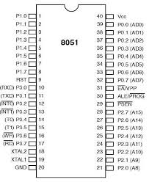
The most important part of a microcontroller is a central processing unit with a word length ranging from 4-bit to 64-bit and in some modern microcontrollers the word length goes even beyond the limit of 64-bit. A timer is one other constituent of a microcontroller. There is a watchdog timer. Memory spaces such as RAM, ROM, EEPROM, and EPROM are there to store data and programs. For data storage, volatile memory RAM is used while for the program and operating parameter storage ROM and other memory spaces are used.
CPU: Being regarded as the brain of the microcontroller, central processing unit fetches, decodes and executes the instructions. It coordinates various activities taking place in the microcontroller.
I/O ports: There are several parallel input/output ports in a microcontroller. They are used to interface various peripherals such as printers, external memories, LEDs and LCDs to the microcontroller. Apart from parallel ports, there are serial ports to interface serially connected peripherals with the microcontroller.
Memory: As in the case of a microprocessor, a microcontroller has spaces for memories such as RAM, ROM including EEROM and EPROM. It also allocates a certain amount of flash memory to store program source code.
Timers and counters: These are the fascinating constituent parts of a microcontroller. Timers and counters are used in operations which include modulation, clock functions, frequency generation and measuring and pulse generation.
Analog to digital converters (ADCs): Such converters are useful while converting the output of a sensor which would be in analog form.
Digital to analog converter (DAC): The working of a DAC is just the reverse of an analog to digital converter. As it is obvious, the output will be an analog signal which can be used to control the analog peripherals such a motor.

Features of a Microcontroller
The main advantage of a CISC (complex instruction set computer) architecture, with which the modern microcontrollers are built, is the macro-type instructions. A macro instruction can be used in a program replacing a number of instructions.
Latest microcontrollers are operated at lesser power consumption. Usually, they can support a working voltage of 1.8-5.5 V.
Advanced memory is another feature of a microcontroller. Use of ROM memories like EEPROM and EPROM (flash memory) make it more reliable and user-friendly. While EEPROM is a relatively slow memory, EPROM is faster. Fact that it allows more erase/write cycles also makes it more usable.

Advantages
The main advantage of a microcontroller is that the low cost with all the integral parts mounted together on a single chip. The design makes it more compact and easy to use. The easiness of using a microcontroller and the relatively easy maintenance process also make it more reliable. Almost all the pins in a microcontroller are programmable and it makes the microcontroller a lot user-friendly. Simplicity while interfacing ROM, RAM, and I/O ports. Easiness of troubleshooting and a minimal time requirement for various operations are other crucial advantages.

Disadvantages
Since it contains all the components on a single chip, microcontrollers are having relatively complex architecture. Microcontrollers are not suitable to interface high power devices directly and they can only perform the limited number of operations simultaneously.

Microcontroller

In a microcontroller CPU, RAM, ROM, and other peripherals are embedded on a single chip.
At times it is termed a mini computer or a computer on a single chip.
Some giants in the manufacturing business of microcontrollers are ATMEL, microchip, TI, Free scale, Philips, Motorola etc.
Designed to perform specific tasks. i.e., the relationship between the input and output is defined.
Since the applications are very specific, they need small resources like RAM, ROM, and I/O ports and hence can be embedded on a single chip.
The clock speed of a microcontroller varies from a few MHz to 30-50 MHz.

Types of Microcontrollers
According to the architecture, memory and word size, it can process, microcontrollers are divided into several categories.

Categorization Based on Bit Size

There is an 8-bit microcontroller which executes basic functions such as arithmetic and logic operations. Intel 8051 is an 8-bit microcontroller. Example for a 16-bit microcontroller is Intel 8096. They are more accurate and provide better performance compared to the 8-bit microcontrollers. 32-bit microcontrollers are used to execute higher functions where precise automatic control is required. The best example of such a microcontroller application is implantable medical appliances.

Categorization Based on Memory
According to the memory space inside the microcontroller, the microcontrollers are classified as external memory microcontroller and embedded memory microcontroller.
External memory microcontroller: It does not have all the integral parts fabricated on a single chip, especially the memory. Intel 8031 is such a device which does not have the program memory on the chip.
Embedded memory: As the name indicates it has all the functioning bocks including the program and data memory
fabricated on a single chip. 8051 is an example.
Based on memory architecture, microcontrollers are divided into two: Harvard memory architecture and Princeton memory architecture.

Categorization Based on Instruction Set
There are two classifications based on the instruction set. They are CISC and RISC. CISC is the abbreviated form for complex instruction set computer and RISC is the abbreviated form for reduced instruction set computer. CISC is based on macro instruction sets which mean a single instruction is used to replace a number of instructions. In reduced instruction architecture, the operation time is reduced by minimizing the clock cycle per instruction.
8051: It is the most universally used microcontroller and was introduced by Intel in the year of 1981. It has 40 kb internal ROM and 128 byte RAM. An additional 64 kb of external memory can be interfaced with the microcontroller. The four parallel 8-bit ports of this microcontroller can be easily programmed and addressed. There is a crystal oscillator interfaced to the microcontroller which generates a frequency of 12 MHz. Apart from these components, there is a serial port which is 8-bit sized and two 16-bit timers incorporated in the 8051 microcontrollers.

Applications

Peripheral controller of a PC
Robotics
In bio-medical equipment
In communication system
In automobiles
In fire detection devices
In light and temperature sensing and controlling devices Process control and industrial automation devices
In measuring devices such as volt and current meters

Various Manufacturers of Microcontrollers

- Analog devices- 8051 microcontrollers with the 12-bit analog to digital converter.
- Atmel- 8051, AT91, AVR, AVR32
- Free scale semiconductor-family of microcontrollers ranging from 8-bit to 32-bit
- Infineon technologies- 8-bit microcontrollers based on 8051 and 16-bit ROM and OTP microcontrollers
- Maxim Integrated Products- 75 MHz single-cycle flash 8051 microcontrollers, some low power 16-bit microcontrollers
- Microchip – wide array of 8-bit microcontroller families including PIC12, PIC16, PIC18, and 16- bit PIC 24 microcontroller and PIC32 which is 32-bit microcontrollers.

3.2
Regulated power supply
A regulated power supply is an embedded circuit; it converts unregulated AC (Alternating Current) into a constant DC. With the help of a rectifier it converts AC supply into DC. Its function is to supply a stable voltage (or less often current), to a circuit or device that must be operated within certain power supply limits. The output from the regulated power supply may be alternating or unidirectional, but is nearly always DC (Direct Current)
The type of stabilization used may be restricted to ensuring that the output remains within certain limits under various load conditions, or it may also include compensation for variations in its own supply source. The latter is much more common today
Today almost every electronic device needs a DC supply for its smooth operation and they need to be operated within certain power supply limits. This required DC voltage or DC supply is derived from single phase ac mains.
A regulated power supply can convert unregulated an AC (alternating current or voltage) to a constant DC (direct current or voltage). A regulated power supply is used to ensure that the output remains constant even if the input changes.
A regulated DC power supply is also called as a linear power supply; it is an embedded circuit and consists of various blocks.

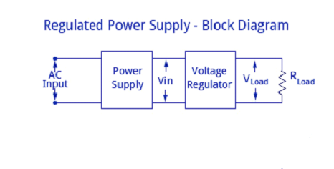
INTRODUCTION
Almost all basic household electronic circuits need an unregulated AC to be converted to constant DC, in order to operate the electronic device. All devices will have a certain power supply limit and the electronic circuits inside these devices must be able to supply a constant DC voltage within this limit. This DC supply is regulated and limited in terms of voltage and current. But the supply provided from mains may be fluctuating and could easily break down the electronic equipment, if not properly limited. This work of converting an unregulated alternating current (AC) or voltage to a limited Direct current (DC) or voltage to make the output constant regardless of the fluctuations in input, is done by a regulated power supply circuit.
All the active and passive electronic devices will have a certain DC operating point (Q-point or Quiescent point), and this point must be achieved by the source of DC power.
The DC power supply is practically converted to each and every stage in an electronic system. Thus a common requirement for all these phases will be the DC power supply. All low power system can be run with a battery. But, for a long time operating devices, batteries could prove to be costly and complicated. The best method used is in the form of an unregulated power supply –a combination of a transformer, rectifier and a filter. The diagram is shown below.

3.3
LED
Currently the LED lamp is popular due to its efficiency and many believe it is a 'new' technology. The LED as we know it has been around for over 50 years. The recent development of white LEDs is what has brought it into the public eye as a replacement for other white light sources.
What is it??
As is evident from its name, LED (Light Emitting Diode) is basically a small light emitting device that comes under “active” semiconductor electronic components. It’s quite comparable to the normal general purpose diode, with the only big difference being its capability to emit light in different colors. The two terminals (anode and cathode) of a LED when connected to a voltage source in the correct polarity may produce lights of different colors, as per the semiconductor substance used inside it
Working Principle:
A light-emitting diode is a two-lead semiconductor light source. It is a p–n junction diode that emits light when activated. When a suitable voltage is applied to the leads, electrons are able to recombine with electron holes within the device, releasing energy in the form of photons. This effect is called electroluminescence, and the color of the light (corresponding to the energy of the photon) is determined by the energy band gap of the semiconductor.
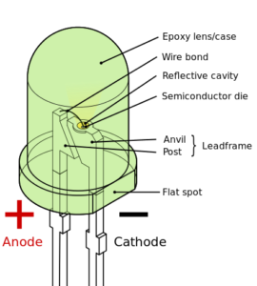
Working in a nutshell:
- The material used in LEDs is basically aluminum-gallium-arsenide (AlGaAs). In its original state, the atoms of this material are strongly bonded. Without free electrons, conduction of electricity becomes impossible here.
- By adding an impurity, which is known as doping, extra atoms are introduced, effectively disturbing the balance of the material.
- These impurities in the form of additional atoms are able either to provide free electrons (N-type) into the system or suck out some of the already existing electrons from the atoms (P-Type) creating “holes” in the atomic orbits. In both ways the material is rendered more conductive. Thus in the influence of an electric current in N-type of material, the electrons are able to travel from anode (positive) to the cathode (negative) and vice versa in the P-type of material. Due to the virtue of the semiconductor property, current will never travel in opposite directions in the respective cases.
- From the above explanation, it’s clear that the intensity of light emitted from a source (LED in this case) will depend on the energy level of the emitted photons which in turn will depend on the energy released by the electrons jumping in between the atomic orbits of the semiconductor material.
- We know that to make an electron shoot from lower orbital to higher orbital its energy level is required to be lifted. Conversely, if the electrons are made to fall from the higher to the lower orbitals, logically energy should be released in the process.
- In LEDs, the above phenomenon is well exploited. In response to the P-type of doping, electrons in LEDs move by falling from the higher orbitals to the lower ones releasing energy in the form of photons i.e. light. The farther these orbitals are apart from each other, the greater the intensity of the emitted light.
Different wavelengths involved in the process determine the different colors produced from the LEDs. Hence, light emitted by the device depends on the type of semiconductor material used.
Infrared light is produced by using Gallium Arsenide (GaAs) as a semiconductor. Red or yellow light is produced by using Gallium-Arsenide-Phosphorus (GaAsP) as a semiconductor. Red or green light is produced by using Gallium-Phosphorus (GaP) as a semiconductor.
Advantages of LEDs:
1. Very low voltage and current are enough to drive the LED.
Voltage range – 1 to 2 volts. Current – 5 to 20 milliamperes.
2. Total power output will be less than 150 milliwatts.
3. The response time is very less – only about 10 nanoseconds.
4. The device does not need any heating and warm up time.
5. Miniature in size and hence lightweight.
6. Have a rugged construction and hence can withstand shock and vibrations.
7. An LED has a lifespan of more than 20 years.

3.4
Servo Motors

The servo motor is most commonly used for high technology devices in the industrial application like automation technology. It is a self contained electrical device, that rotate parts of a machine with high efficiency and great precision. The output shaft of this motor
can be moved to a particular angle. Servo motors are mainly used in home electronics, toys, cars, airplanes, etc.This article discusses about what is a servo motor, servo motor working, servo motor types and its applications

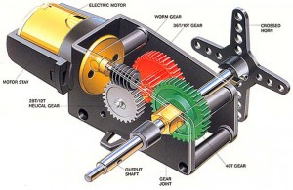
Servo motor

Applications of Servo Motor
The servo motor is small and efficient, but serious to use in some applications like precise position control. This motor is controlled by a pulse width modulator signal. The applications of servo motors mainly involve in computers, robotics, toys, CD/DVD players, etc. These motors are extensively used in those applications where a particular task is to be done frequently in an exact manner.
3.5
Ultra sonic sensor
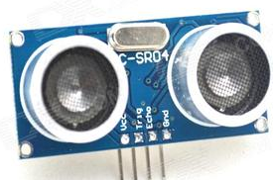
As the name indicates, ultrasonic sensors measure distance by using ultrasonic waves.
The sensor head emits an ultrasonic wave and receives the wave reflected back from the target. Ultrasonic Sensors measure the distance to the target by measuring the time between the emission and reception.
An optical sensor has a transmitter and receiver, whereas an ultrasonic sensor uses a single ultrasonic element for both emission and reception. In a reflective model ultrasonic sensor, a single oscillator emits and receives ultrasonic waves alternately. This enables miniaturization of the sensor head
The distance can be calculated with the following formula:
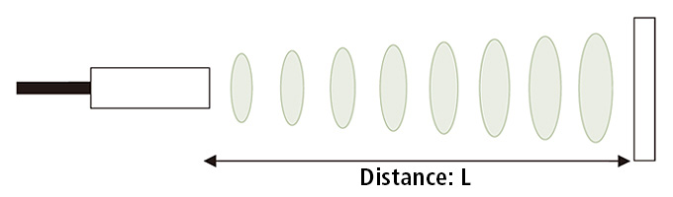

Distance L = 1/2 × T × C
where L is the distance, T is the time between the emission and reception, and C is the sonic speed. (The value is multiplied by 1/2 because T is the time for go-and-return distance.)

How does an Ultrasonic Distance Sensor work?
The Ultrasonic Sensor sends out a high-frequency sound pulse and then times how long it takes for the echo of the sound to reflect back. The sensor has 2 openings on its front. One opening transmits ultrasonic waves, (like a tiny speaker), the other receives them, (like a tiny microphone).
The speed of sound is approximately 341 meters (1100 feet) per second in air. The ultrasonic sensor uses this information along with the time difference between sending and receiving the sound pulse to determine the distance to an object. It uses the following mathematical equation:
Distance = Time x Speed of Sound divided by 2
Time = the time between when an ultrasonic wave is transmitted and when it is received
You divide this number by 2 because the sound wave has to travel to the object and back.

3.6
Buzzer
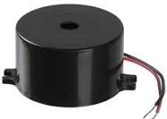
A buzzer or beeper is an audio signaling device, which may be mechanical, electromechanical, or piezoelectric (piezo for short). Typical uses of buzzers and beepers include alarm devices, timers, and confirmation of user input such as a mouse click or keystroke.
piezo electric element is a crystal or ceramic that deforms slightly when a voltage is applied to it. So if you supply an AC voltage at a few kilohertz, it deforms back and forth at the same speed as the AC signal, and produces an audible sound.
The same effect works in reverse. If you deform a piezo, it generates a voltage. This was the principle of “crystal” microphones and gramophone pickups, probably before your time. It’s also the principle of gas igniters - when you press the button a spring loaded hammer snaps against a piezo, and the sudden deformation generates thousands of volts which cause a spark.
Quartz is a piezo crystal, and it exhibits both these effects. If you grind it very thin it can have a resonant frequency in the megahertz and be made part of an oscillator. An electronic driver applies a voltage that deforms it, then when the voltage is removed the crystal deforms back and overshoots, generating a voltage that is fed back to the oscillator and keeps it going at the resonant frequency. You probably have about six of these in your phone.

3.7
Hall Effect Sensor
Hall Effect Sensors consist basically of a thin piece of rectangular p-type semiconductor material such as gallium arsenide (GaAs), indium antimonide (InSb) or indium arsenide (InAs) passing a continuous current through itself. When the device is placed within a magnetic field, the magnetic flux lines exert a force on the semiconductor material which deflects the charge carriers, electrons and holes, to either side of the semiconductor slab. This movement of charge carriers is a result of the magnetic force they experience passing through the semiconductor material.
As these electrons and holes move side wards a potential difference is produced between the two sides of the semiconductor material by the build-up of these charge carriers. Then the movement of electrons through the semiconductor material is affected by the presence of an external magnetic field which is at right angles to it and this effect is greater in a flat rectangular shaped material.
The effect of generating a measurable voltage by using a magnetic field is called the Hall Effect after Edwin Hall who discovered it back in the 1870’s with the basic physical principle underlying the Hall effect being Lorentz force. To generate a potential difference across the device the magnetic flux lines must be perpendicular, (90º) to the flow of current and be of the correct polarity, generally a south pole.
The Hall effect provides information regarding the type of magnetic pole and magnitude of the magnetic field. For example, a south pole would cause the device to produce a voltage output while a north pole would have no effect. Generally, Hall Effect sensors and switches are designed to be in the “OFF”, (open circuit condition) when there is no magnetic field present. They only turn “ON”, (closed circuit condition) when subjected to a magnetic field of sufficient strength and polarity.

Hall Effect Magnetic Sensor
The output voltage, called the Hall voltage, (V_{H}) of the basic Hall Element is directly proportional to the strength of the magnetic field passing through the semiconductor material (output ∝ H). This output voltage can be quite small, only a few microvolts even when subjected to strong magnetic fields so most commercially available Hall effect devices are manufactured with built-in DC amplifiers, logic switching circuits and voltage regulators to improve the sensors sensitivity, hysteresis and output voltage. This also allows the Hall effect sensor to operate over a wider range of power supplies and magnetic field conditions.

The Hall Effect Sensor
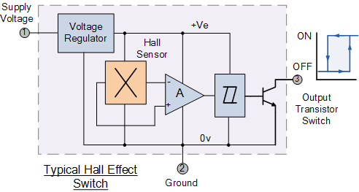
Hall Effect Sensors are available with either linear or digital outputs. The output signal for linear (analogue) sensors is taken directly from the output of the operational amplifier with the output voltage being directly proportional to the magnetic field passing through the Hall sensor. This output Hall voltage is given as:
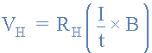
- Where:  - V_{H} is the Hall Voltage in volts  - R_{H} is the Hall Effect co-efficient  - I is the current flow through the sensor in amps  - t is the thickness of the sensor in mm  - B is the Magnetic Flux density in Teslas | 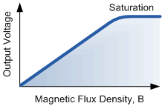
Linear or analogue sensors give a continuous voltage output that increases with a strong magnetic field and decreases with a weak magnetic field. In linear output Hall effect sensors, as the strength of the magnetic field increases the output signal from the amplifier will also increase until it begins to saturate by the limits imposed on it by the power supply. Any additional increase in the magnetic field will have no effect on the output but drive it more into saturation.
Digital output sensors on the other hand have a Schmitt-trigger with built in hysteresis connected to the op-amp. When the magnetic flux passing through the Hall sensor exceeds a pre-set value the output from the device switches quickly between its “OFF” condition to an “ON” condition without any type of contact bounce. This built-in hysteresis eliminates any oscillation of the output signal as the sensor moves in and out of the magnetic field. Then digital output sensors have just two states, “ON” and “OFF”.
There are two basic types of digital Hall effect sensor, Bipolar and Unipolar. Bipolar sensors require a positive magnetic field (south pole) to operate them and a negative field (north pole) to release them while unipolar sensors require only a single magnetic south pole to both operate and release them as they move in and out of the magnetic field.
Most Hall effect devices can not directly switch large electrical loads as their output drive capabilities are very small around 10 to 20mA. For large current loads an open-collector (current sinking) NPN Transistor is added to the output.
This transistor operates in its saturated region as a NPN sink switch which shorts the output terminal to ground whenever the applied flux density is higher than that of the “ON” pre-set point.
The output switching transistor can be either an open emitter transistor, open collector transistor configuration or both providing a push-pull output type configuration that can sink enough current to directly drive many loads, including relays, motors, LEDs, and lamps.

Hall Effect Applications
Hall effect sensors are activated by a magnetic field and in many applications the device can be operated by a single permanent magnet attached to a moving shaft or device. There are many different types of magnet movements, such as “Head-on”, “Sideways”, “Push-pull” or “Push-push” etc sensing movements. Which every type of configuration is used, to ensure maximum sensitivity the magnetic lines of flux must always be perpendicular to the sensing area of the device and must be of the correct polarity.
Also to ensure linearity, high field strength magnets are required that produce a large change in field strength for the required movement. There are several possible paths of motion for detecting a magnetic field, and below are two of the more common sensing configurations using a single magnet: Head-on Detection and Sideways Detection.

Head-on Detection
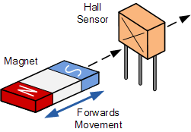
As its name implies, “head-on detection” requires that the magnetic field is perpendicular to the hall effect sensing device and that for detection, it approaches the sensor straight on towards the active face. A sort of “head-on” approach.
This head-on approach generates an output signal, V_{H} which in the linear devices represents the strength of the magnetic field, the magnetic flux density, as a function of distance away from the hall effect sensor. The nearer and therefore the stronger the magnetic field, the greater the output voltage and vice versa.
Linear devices can also differentiate between positive and negative magnetic fields. Non-linear devices can be made to trigger the output “ON” at a pre-set air gap distance away from the magnet for indicating positional detection.

Sideways Detection
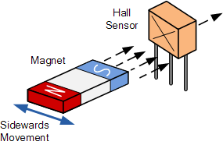
The second sensing configuration is “sideways detection”. This requires moving the magnet across the face of the Hall effect element in a sideways motion.
Sideways or slide-by detection is useful for detecting the presence of a magnetic field as it moves across the face of the Hall element within a fixed air gap distance for example, counting rotational magnets or the speed of rotation of motors.
Depending upon the position of the magnetic field as it passes by the zero field centre line of the sensor, a linear output voltage representing both a positive and a negative output can be produced. This allows for directional movement detection which can be vertical as well as horizontal.
There are many different applications for Hall Effect Sensors especially as proximity sensors. They can be used instead of optical and light sensors were the environmental conditions consist of water, vibration, dirt or oil such as in automotive applications. Hall effect devices can also be used for current sensing.
We know from the previous tutorials that when a current passes through a conductor, a circular electromagnetic field is produced around it. By placing the Hall sensor next to the conductor, electrical currents from a few milliamps into thousands of amperes can be measured from the generated magnetic field without the need of large or expensive transformers and coils.
As well as detecting the presence or absence of magnets and magnetic fields, Hall effect sensors can also be used to detect ferromagnetic materials such as iron and steel by placing a small permanent “biasing” magnet behind the active area of the device. The sensor now sits in a permanent and static magnetic field, and any change or disturbance to this magnetic field by the introduction of a ferrous material will be detected with sensitivities as low as mV/G possible.
There are many different ways to interface Hall effect sensors to electrical and electronic circuits depending upon the type of device, whether digital or linear. One very simple and easy to construct example is using a Light Emitting Diode as shown below.

Positional Detector
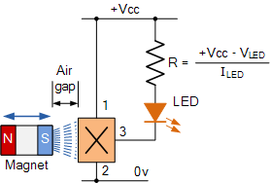
This head-on positional detector will be “OFF” when there is no magnetic field present, (0 gauss). When the permanent magnets south pole (positive gauss) is moved perpendicular towards the active area of the Hall effect sensor the device turns “ON” and lights the LED. Once switched “ON” the Hall effect sensor stays “ON”.
To turn the device and therefore the LED “OFF” the magnetic field must be reduced to below the release point for unipolar sensors or exposed to a magnetic north pole (negative gauss) for bipolar sensors. The LED can be replaced with a larger power transistor if the output of the Hall Effect Sensor is required to switch larger current loads.

CHAPTER: 4
SOFTWARE DESCRIPTION
4.1
Arduino IDE
The Arduino integrated development environment (IDE) is a cross-platform application (for Windows, macOS, Linux) that is written in the programming language Java. It is used to write and upload programs to Arduino board.
The source code for the IDE is released under the GNU General Public License, version 2. The Arduino IDE supports the languages C and C++ using special rules of code structuring. The Arduino IDE supplies a software library from the Wiring project, which provides many common input and output procedures. User-written code only requires two basic functions, for starting the sketch and the main program loop, that are compiled and linked with a program stub main() into an executable cyclic executive program with the GNU toolchain, also included with the IDE distribution. The Arduino IDE employs the program avrdude to convert the executable code into a text file in hexadecimal encoding that is loaded into the Arduino board by a loader program in the board's firmware

4.2
Usage of Adruino IDE
If you're creating tutorials, managing a local community of Arduino users, opening up an Arduino-focused page online (i.e. social networks) you can use the Arduino Community Logo! This will allow people identify better what comes directly from us, and what comes from the community.

I want to design my own board, what should I do?

The reference designs for the Arduino boards are available from their specific product pages. They're licensed under a Creative Commons Attribution Share-Alike license, so you are free to use and adapt them for your own needs without asking permission or paying a fee. If you're looking to make something of interest to the community, we'd encourage you to discuss your ideas on the hardware development forum so that potential users can offer suggestions.

What should I call my boards?

If you're making your own board, come up with your own name! This will allow people identify you with your products and help you to build a brand. Be creative: try to suggest what people might use the board for, or emphasize the form factor, or just pick a random word that sounds cool. "Arduino" is a trademark of Arduino LLC and should not be used for unofficial variants. If you're interested in having your design included in the official Arduino product line, please see the so you want to make an Arduino document and contact the Arduino team. While unofficial products should not have "Arduino" in their name, it's okay to describe your product in relation to the Arduino project and platform. Here are a few guidelines that explain which uses we consider reasonable.
4.3
Dumping of program into Arduino board
Program an Arduino in A Few Simple Steps
STEP 1
Arduino microcontrollers come in a variety of types. The most common is the Arduino UNO, but there are specialized variations. Before you begin building, do a little research to figure out which version will be the most appropriate for your project
STEP 2
To begin, you'll need to install the Arduino Programmer, aka the integrated development environment (IDE).
STEP 3
Connect your Arduino to the USB port of your computer. This may require a specific USB cable. Every Arduino has a different virtual serial-port address, so you 'all need to reconfigure the port if you're using different Arduino.
STEP 4
Set the board type and the serial port in the Arduino Programmer.
STEP 5
Test the microcontroller by using one of the preloaded programs, called sketches, in the Arduino Programmer. Open one of the example sketches, and press the upload button to load it. The Arduino should begin responding to the program: If you've set it to blink an LED light, for example, the light should start blinking.
STEP 6
To upload new code to the Arduino, either you'll need to have access to code you can paste into the programmer, or you'll have to write it yourself, using the Arduino programming language to create your own sketch. An Arduino sketch usually has five parts: a header describing the sketch and its author; a section defining variables; a setup routine that sets the initial conditions of variables and runs preliminary code; a loop routine, which is where you add the main code that will execute repeatedly until you stop running the sketch; and a section where you can list other functions that activate during the setup and loop routines. All sketches must include the setup and loop routines.
STEP 7
Once you've uploaded the new sketch to your Arduino, disconnect it from your computer and integrate it into your project as directed.

CHAPTER: 5
POJECT CIRCUIT DIAGRAM

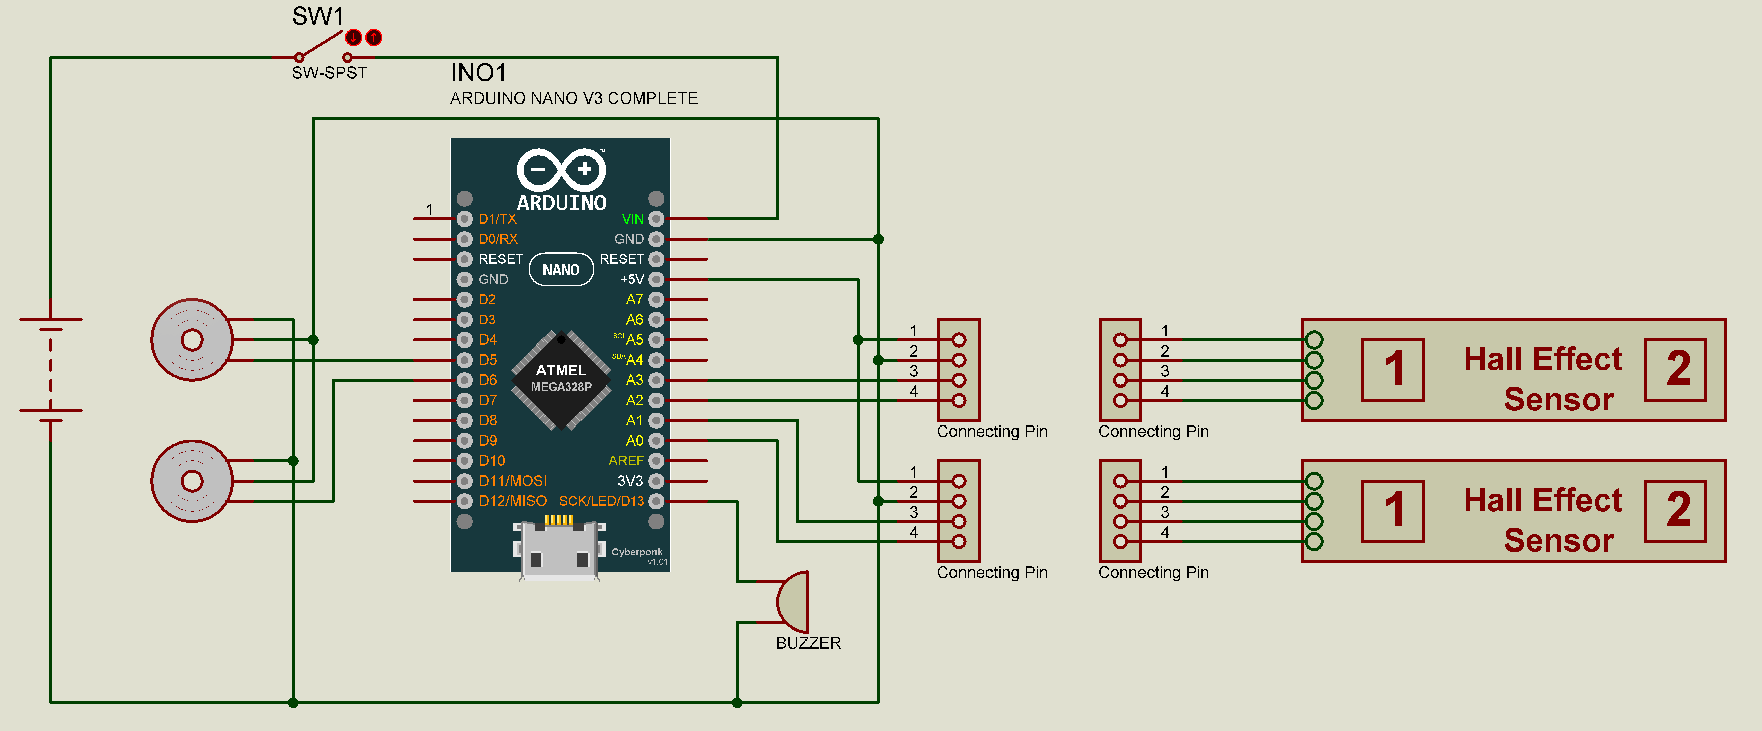

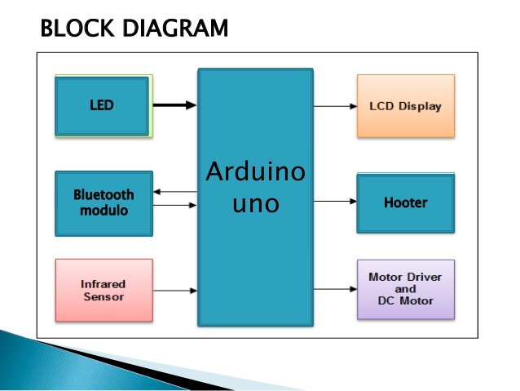

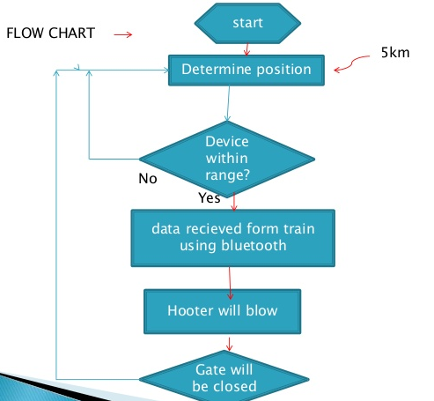

CHAPTER: 6
ADVANTAGES, DISADVANTAGES AND APPLICATIONS
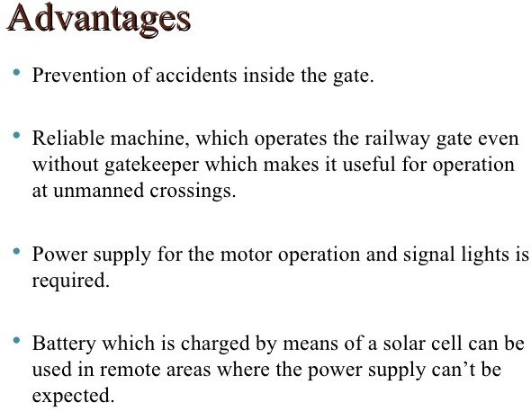
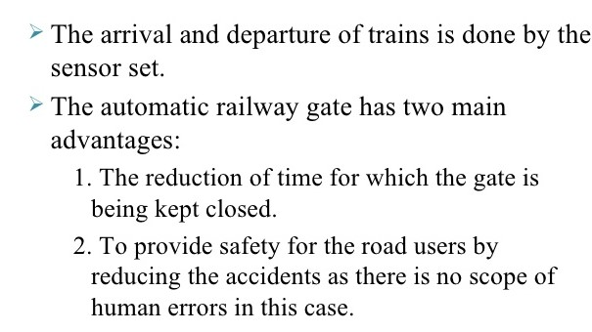

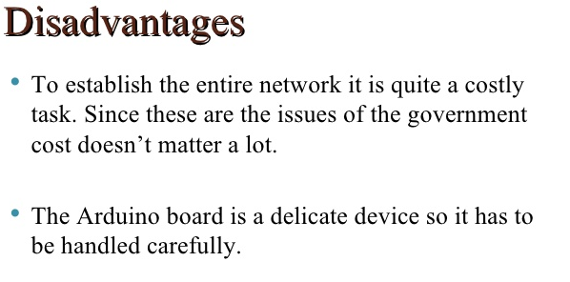
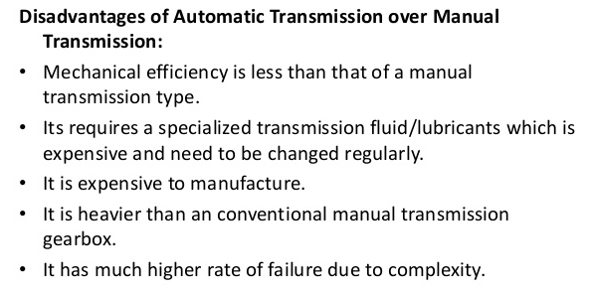
Applications
This system is mainly used in Railways
This system can replace the manual operated train gates

CHAPTER 7:

FUTURE PROSPECTS AND
REFERENCES

In future this system may comes into use for simple and more automation, let us hope that this system can make more automation. By this we can overcome road and railway accidents which occurs near railway crossings and this can used for improve automation of railway systems.

REFERENCES
Kona.Deeraj Mahendra
Shaik.Thasleem
WWW.GOOGLE.COM
WWW.WIKIPEDIA.COM
WWW.ELECTRONICSHUB.ORG
http://prudvigande.blogspot.com/

